**Full Stack Engineer**

Assignments

Cognizant Technology Solutions

*Projjwalanka Pramanick (299202)*

RestFulAPI 2 Assignment 21

**Code Snippets:**



**Db Script**



**Screenshots of the Output Step wise:**

1. Add a Book

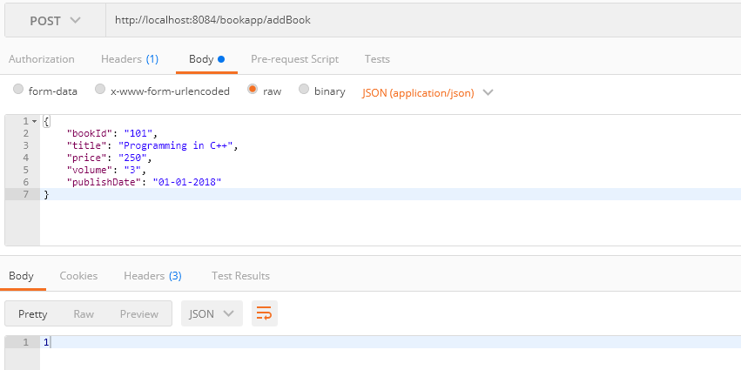

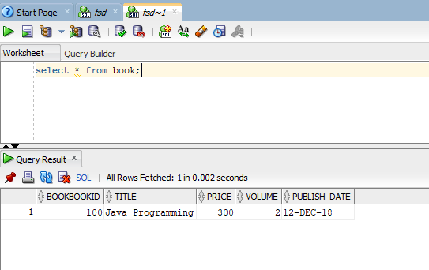

Add Book if book is null

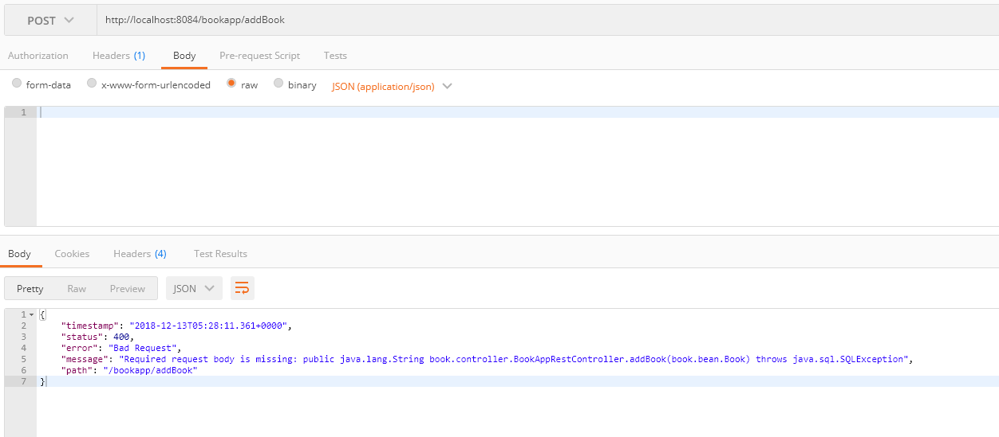

Update Book

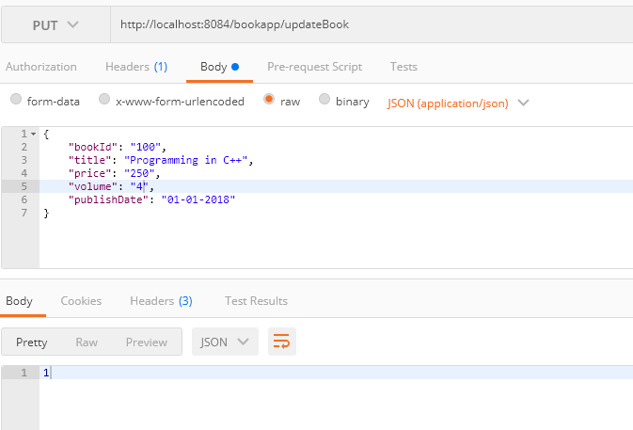

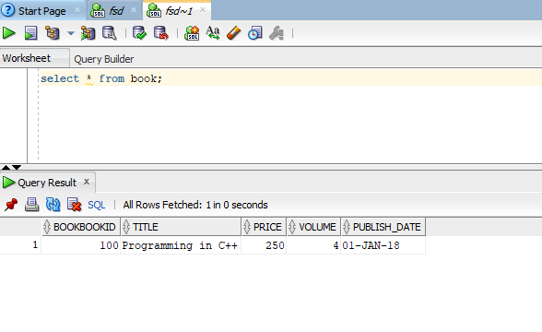

Update Book with non-existing id

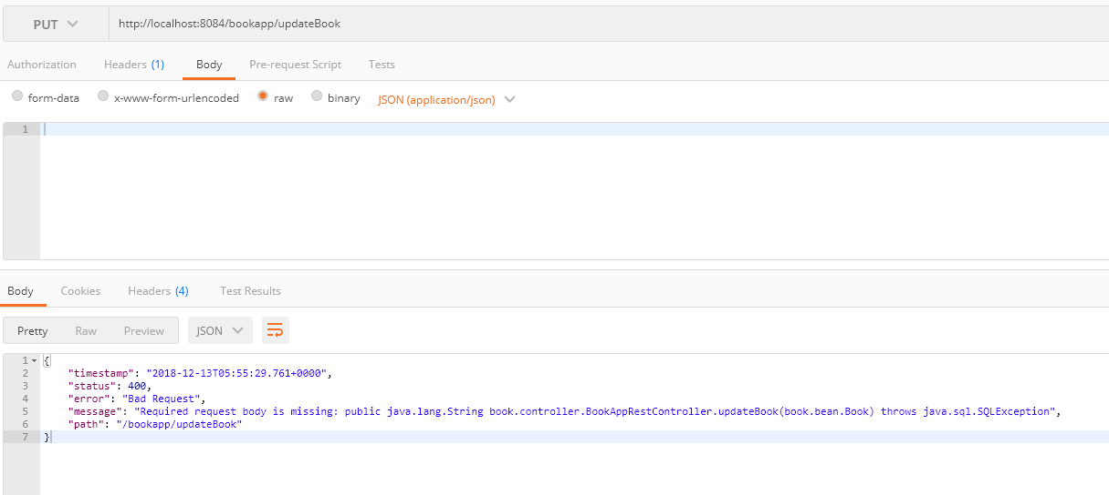

Delete a Book

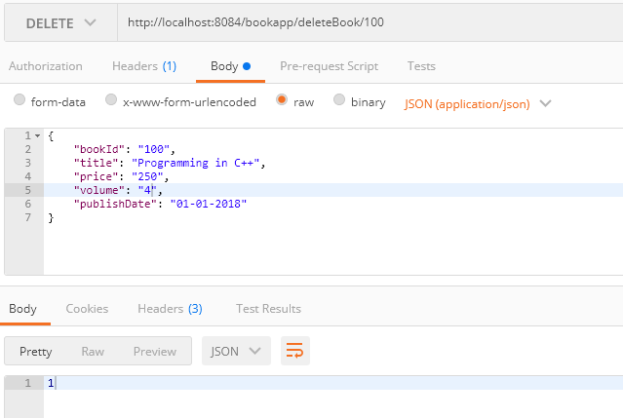

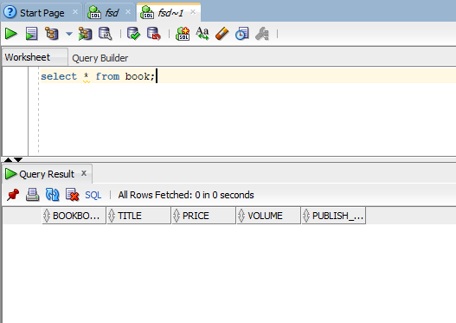

Delete Book with non-existing id

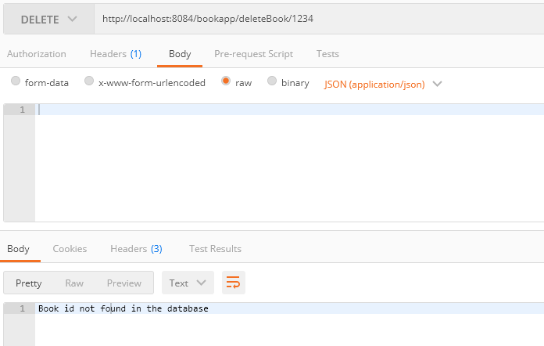

Get All Books

